**DATA Science LAB#2**

**Roll no: 20K-0409**

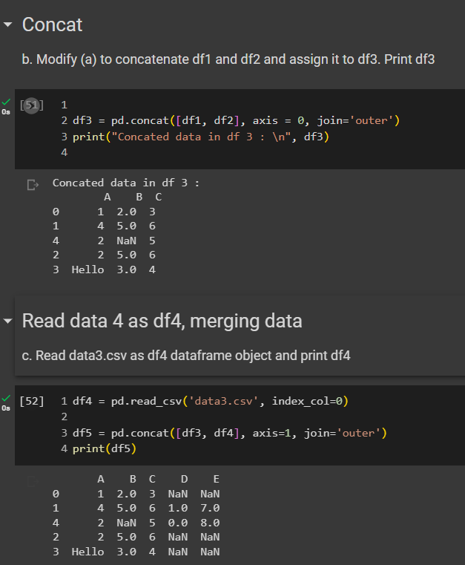**Screen Shots:**

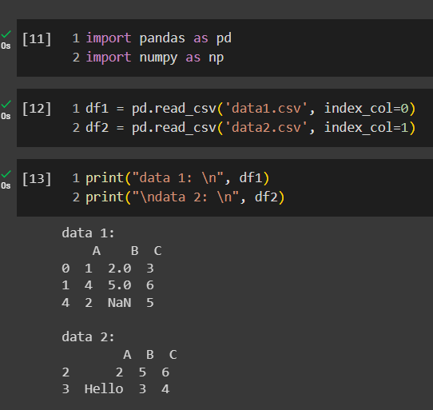Task#1

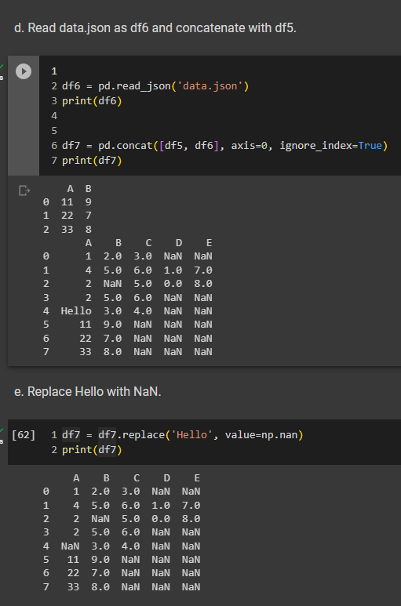

**TASK # 2**

